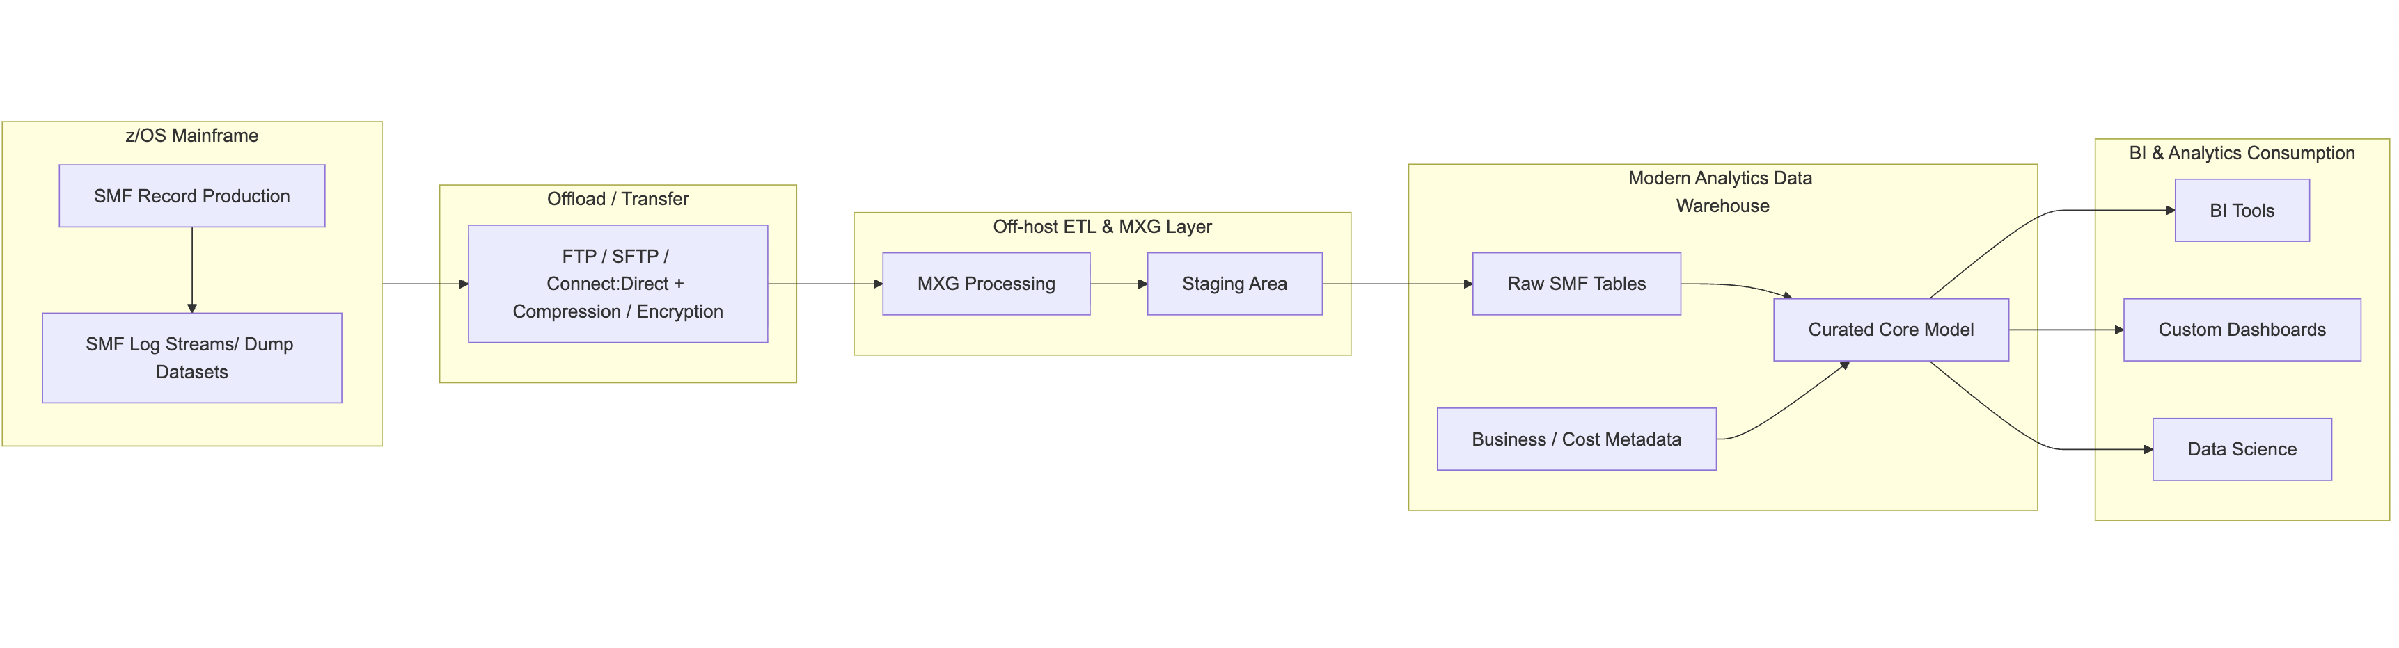
SMTData or EPV for sas mainframe

ChatGPT said:
Here’s a clear comparison between SMTData and EPV for SAS/Mainframe (z/OS) environments.
Both are widely used for capacity management, performance reporting, and cost optimization, but they differ in approach, architecture, and depth.

✅ SMTData vs EPV — Summary
Feature / Focus | SMTData (ITBI – IT Business Intelligence) | EPV (EPV for z/OS, EPV for Cost, EPV for Db2, etc.)
Primary Purpose | Normalize SMF/MF data & integrate with business metrics | Deep performance, capacity, and cost analysis from SMF
Strength | Data model, business alignment, enterprise-wide reporting | Rich technical analytics, automated performance insights
Setup | More flexible, requires configuration & modeling | Faster to value with built-in algorithms
Visualization | Dashboard-oriented (e.g., PowerBI, Qlik) | Built-in HTML reporting + automation
Best For | Organizations wanting enterprise BI from SMF data | Performance/capacity teams needing expert-level reports
SAS Dependency | Often integrates with SAS, can reduce SAS usage | Less dependent on SAS; uses proprietary engines

🔍 Where They Differ

1. Data Handling & Architecture

SMTData
- Builds a normalized enterprise data warehouse from SMF/MF, Db2, CICS, RMF, etc.
- Focuses on data integration more than pure capacity tooling.
- Makes it easy to join SMF with:
  - Business data
  - Finance/cost allocation
  - Application inventories
- Often used in SAS-heavy shops to restructure data pipelines so SAS can be run more efficiently or partially replaced.

EPV
- Reads SMF and produces ready-made technical performance & capacity reports.
- Uses its own engines — no SAS dependency.
- Daily automated report generation (HTML-based).
- Great for identifying anomalies (CPU spikes, WLM changes, I/O trends).

2. Use Cases

✔ If your focus is capacity planning, cost management, technical performance tuning
EPV is typically stronger.
Examples:
- LPAR capacity analysis
- WLM behaviour diagnostics
- CPU/MSU optimization
- Rolling 4HRA control
- Automatic exceptions & alerts

✔ If your focus is analytics, BI, data integration, replacing/optimizing SAS workloads
SMTData is usually the better choice.
Examples:
- Creating unified reporting across IT + business
- Chargeback / showback financial models
- Feeding data into enterprise BI tools
- Modernizing SMF data pipelines beyond SAS

3. Depth of Technical Mainframe Insight
Area | SMTData | EPV
WLM analysis | Moderate | Very strong
RMF/SMF performance | Good | Excellent
Cost optimization | Strong | Very strong
Db2/CICS subsystem analytics | Good | Strong
Cross-platform BI | Excellent | Minimal
EPV is considered more "mainframe-expert-oriented," while SMTData is more "enterprise-BI-oriented."

4. SAS Considerations

If you're already using SAS:
SMTData integrates well because:
- It can feed SAS datasets
- It often replaces custom SAS SMF processing pipelines
- Reduces the cost of SAS-based ETL
EPV minimizes reliance on SAS:
- Most reports are generated in EPV’s own processing engine
- Can reduce SAS CPU usage significantly

📝 Recommendation depending on your situation

✔ If you’re doing SAS-based SMF processing today and want a more flexible BI/ETL platform:
➡ SMTData is usually the better match.

✔ If you want deep automated capacity/performance reports without SAS:
➡ EPV is generally the stronger tool.

✔ If you want both business-level and technical-level reporting:
➡ Many organizations use both, with SMTData as the data warehouse and EPV as the analytic engine.

If you want, I can also provide:
- A side-by-side evaluation specific to your environment
- Guidance based on whether you're focused on SAS reduction, cost optimization, or performance
- A technical breakdown of SMF types each tool handles best
Would you like a more tailored recommendation?

You said:
any other option

ChatGPT said:
Yes — there are several other options besides SMTData and EPV for analysing SMF (or more broadly z/OS) data. Here are a few good alternatives you may want to consider:

1. IBM Z IntelliMagic Vision for z/OS
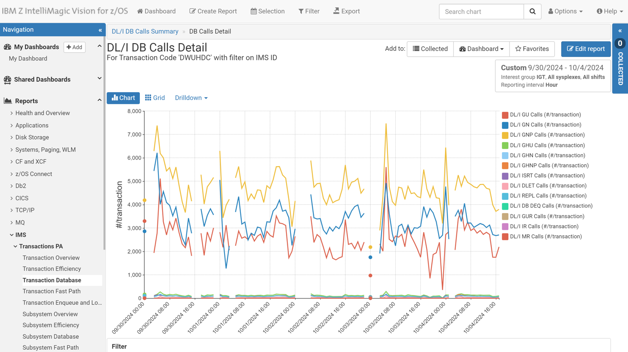
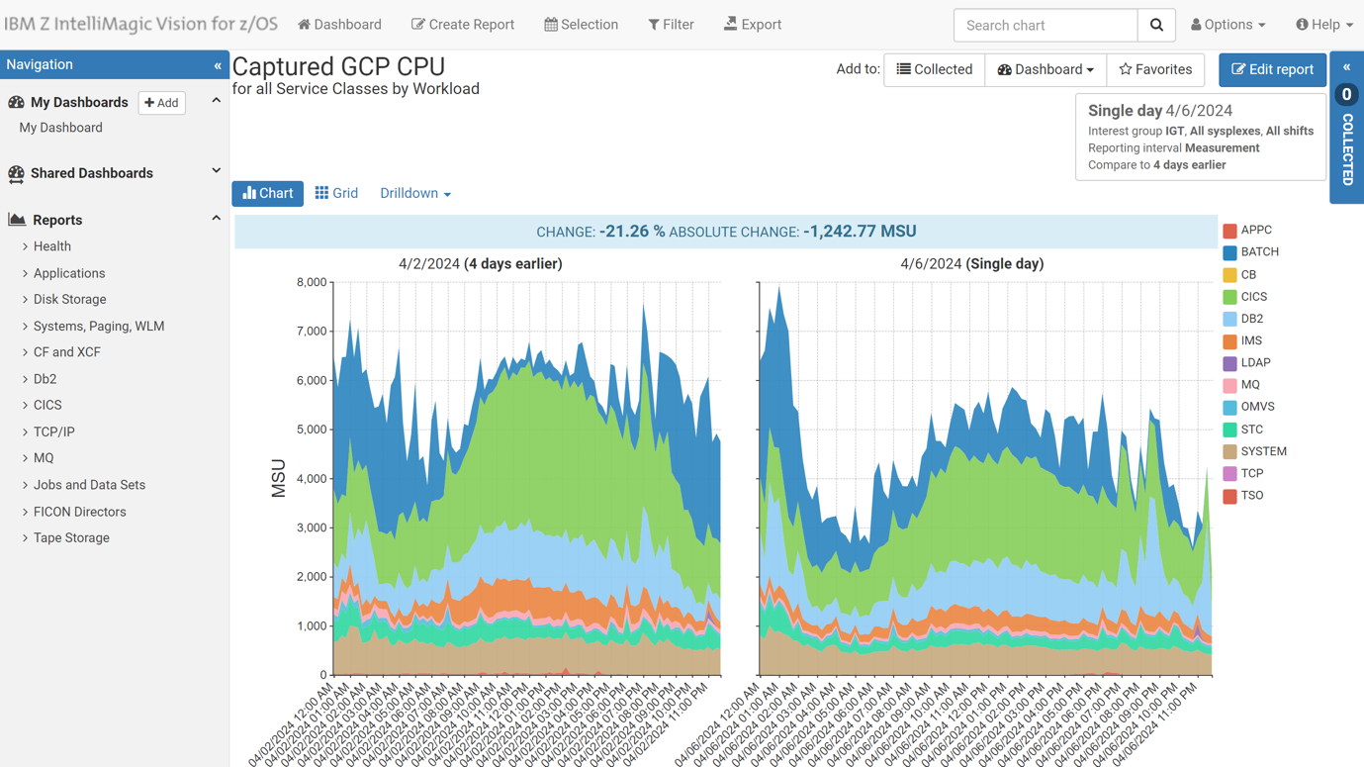
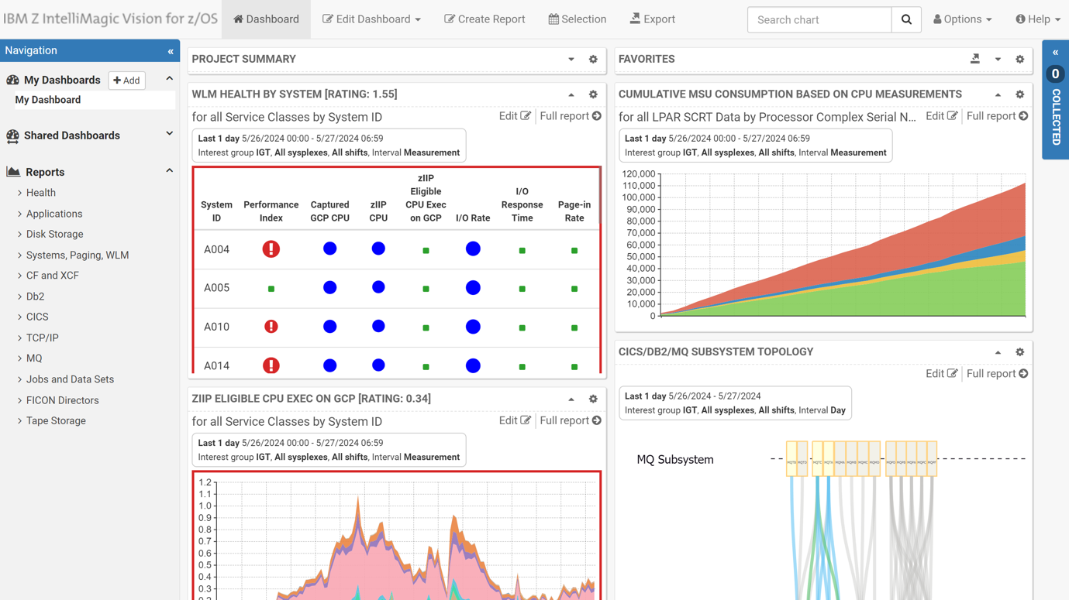
6
What it is: A performance‐analysis tool from IBM (previously from IntelliMagic) designed for IBM Z / z/OS environments — it ingests SMF/RMF data, provides visualisations, anomaly detection, etc. ibm.com+2ibm.com+2
Why consider it:
- Strong on performance & capacity optimisation, risk detection and trending.
- Helps you modernise mainframe instrumentation (which may align with some of your data-analytics/dev skills).
Things to check: Implementation cost, licence model, how it fits your SMF + cost + performance + analytics mix.

2. IBM Z Performance and Capacity Analytics
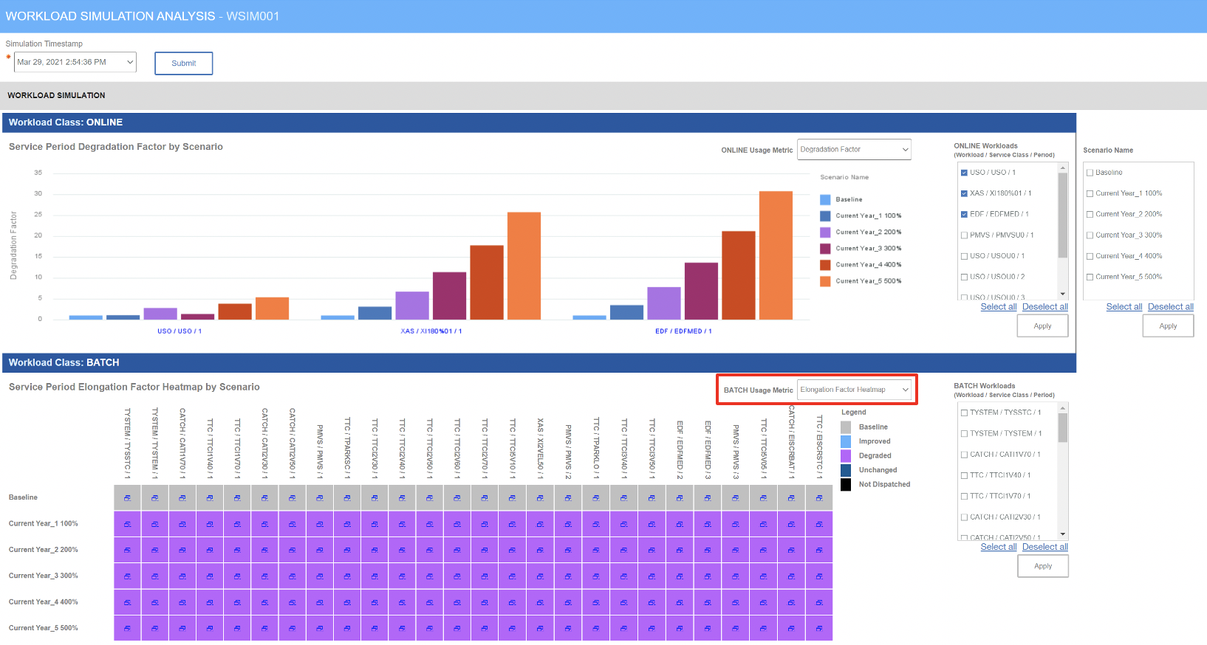
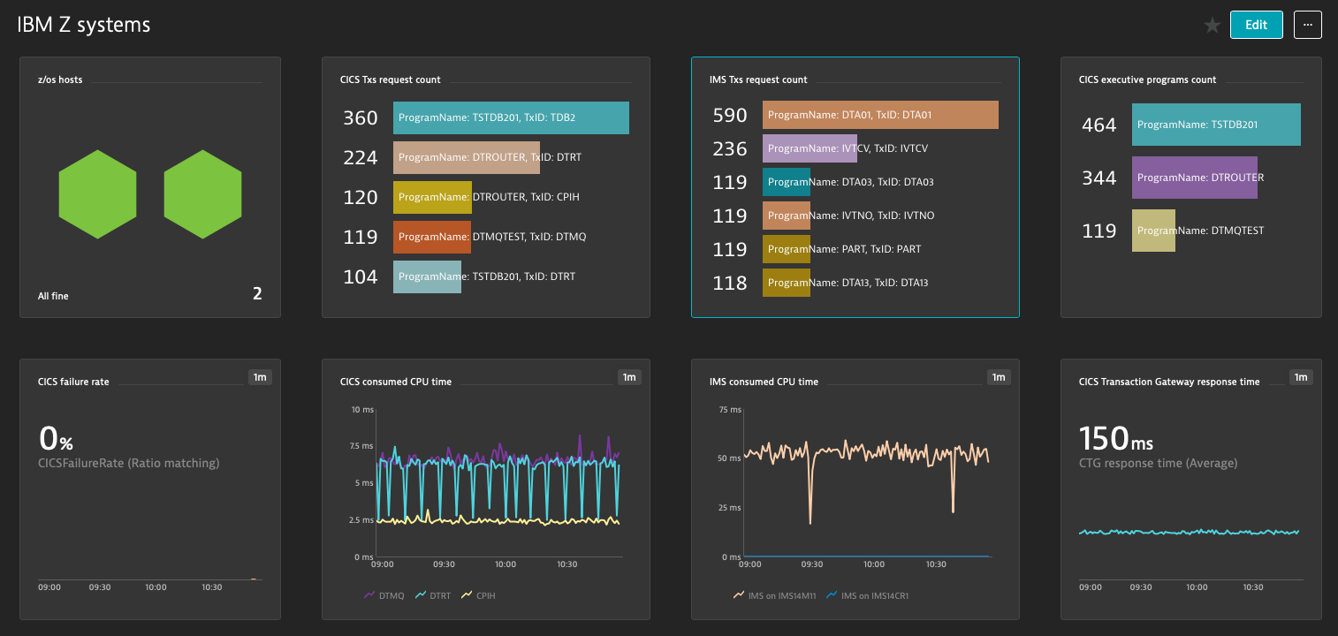
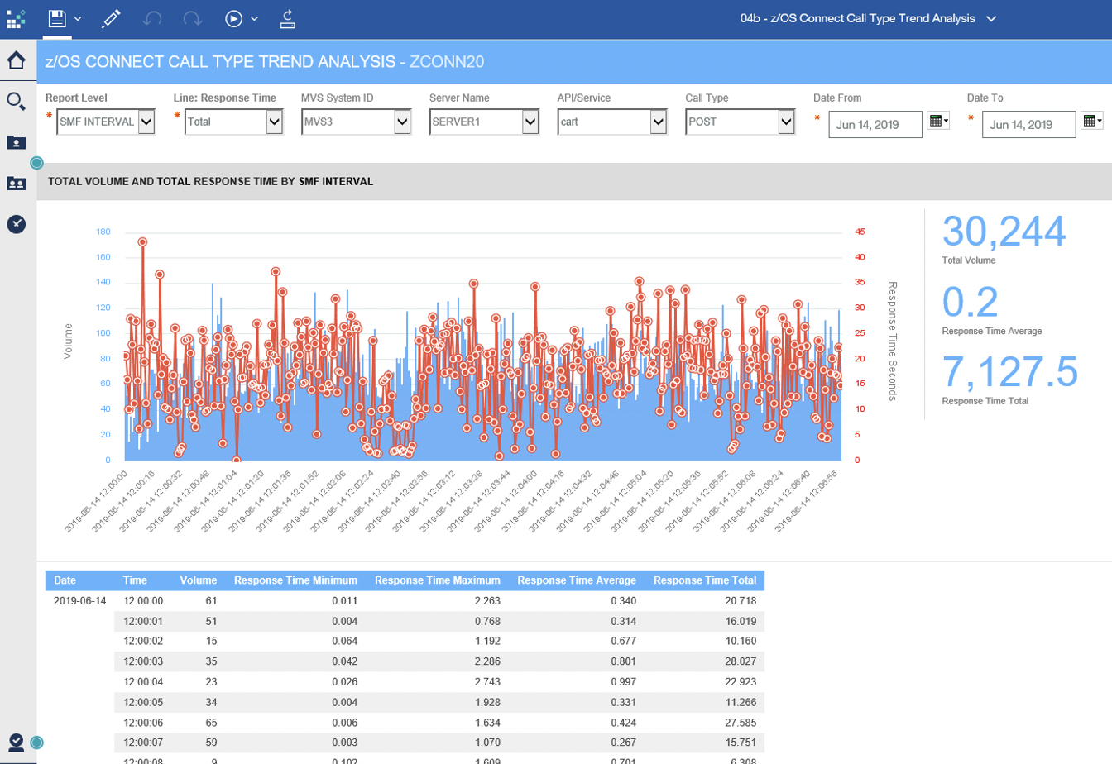
5
What it is: A solution from IBM to collect, curate and report on performance & capacity data for IBM Z systems (including SMF). ibm.com
Why consider it:
- Emphasis on near-real-time collection and forecasting of capacity needs.
- Useful for cost modelling, workload planning, especially if you care about “how many MSUs am I using” and how they trend.
Things to check: Might be more “capacity/cost” oriented than full deep performance analytics; integrate with your existing toolset may require additional work.

3. EasySMF for z/OS (via Splunk)
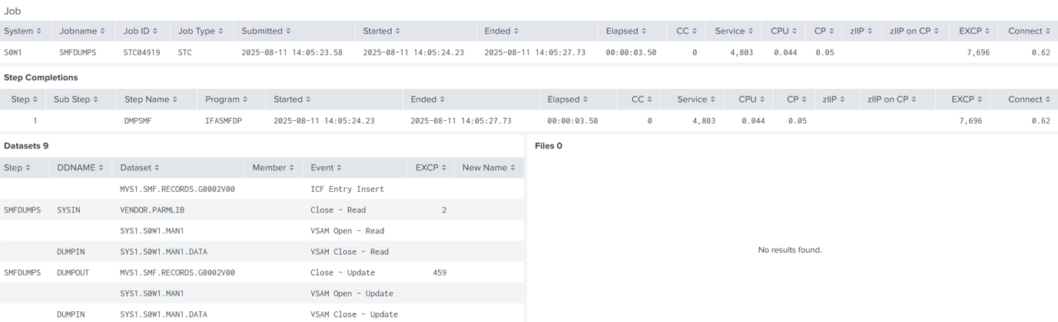
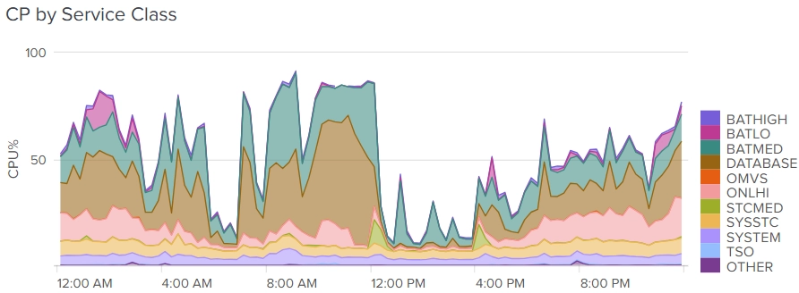
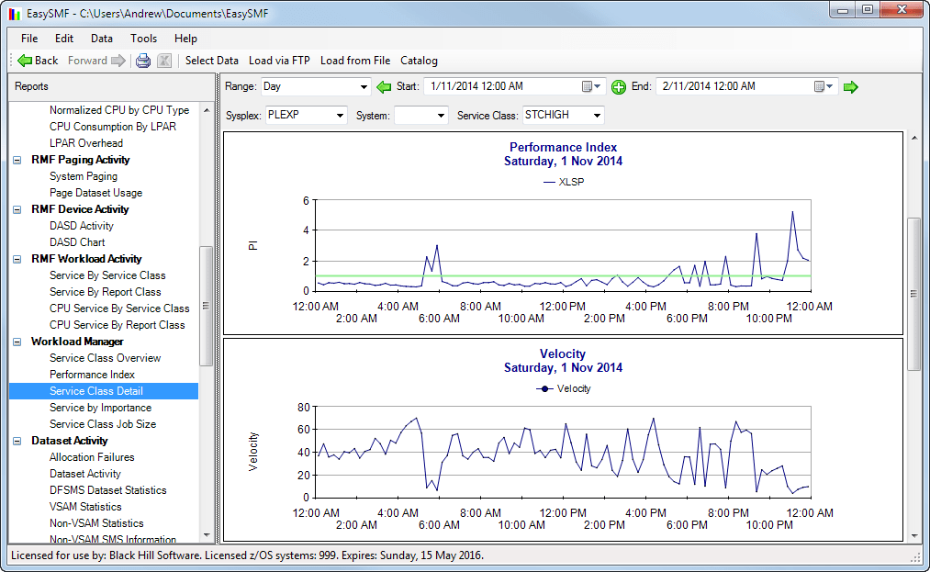
5
What it is: A tool/app (for Splunk) that uses SMF data to produce reports on CPU usage, WLM performance, job accounting, dataset/file access etc. Splunkbase
Why consider it:
- If you already use Splunk (or are moving analytics & observability there) this could integrate nicely.
- More lightweight than large enterprise performance suites—could be good if your needs are moderate or you want to build your own analytics layer.
Things to check: Might lack some of the advanced capacity modelling or deep performance tuning features of major tools.

4. MXG Software
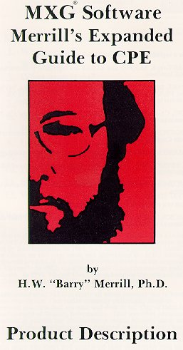

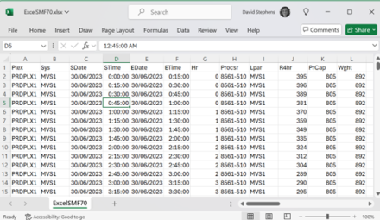
6
What it is: A legacy but still used SAS-based product set for reading SMF data and producing analysis/reporting. Wikipedia
Why consider it:
- If you or your team have strong SAS skills, or you want maximum flexibility (you’re doing a lot of custom work).
- Good for environments that already have SAS infrastructure.
Things to check: Might require more manual work, less “turn-key” than modern tools; may not have as many “smart” automation/analytics features.

🧭 Which one fits your context best?
Since you know that:
- You’re dealing with SMF / mainframe performance/capacity/cost.
- You have background in data analytics, BI, pipeline work.
- You might be looking for flexibility rather than just “black box”.
Here are some tailored pointers:
- If your priority is deep performance/tuning (CPU, WLM, I/O), and you need a tool that serious mainframe performance engineers will use → consider IntelliMagic Vision.
- If your priority is capacity/cost forecasting, budgeting MSUs, trending workloads → IBM Z Performance and Capacity Analytics is strong.
- If you already have or want to leverage a Splunk/observability stack and you favour analytics over full mainframe-tooling overhead → EasySMF could be a fit.
- If you want ultimate flexibility, you are comfortable with SAS and custom pipelines → MXG may still be viable.

If you like, I can pull together a full comparison matrix of 5-10 tools (including ones like BMC, CA, etc) with features, licence cost ballparks, pros/cons — that might help you pick for your project. Would you like me to do that?

You said:
we want to move away from SAS and jobs report generates charts which are not supported by altair SLC

ChatGPT said:
Good decision — moving away from heavy reliance on SAS (and especially when your charting/viewing stack (like Altair SLC) doesn’t fully support it) opens up modern, more flexible tooling. Below are three alternative approaches + what to consider — since you already have strong data/analytics skills (Python, data-engineering, React etc) I’ll emphasise what fits your stack.

🔧 Alternative approaches

1. Use a modern analytics/data-warehouse + BI visualization stack
Since you already work a lot with analytics and you’re comfortable with Python, JS/React etc, you might shift to something like:
- Dump your SMF / mainframe-log data (from MXG, or whatever pipeline you have) into a modern relational or columnar warehouse (e.g., PostgreSQL, MariaDB, Snowflake, BigQuery, etc).
- Use Python (Pandas, PySpark) or ELT to transform and aggregate.
- Use a front-end/BI tool (Power BI, Tableau, Looker, or even React + D3) to build dashboards/charts.
This approach reduces your SAS dependency and gives you full control of visuals, charting libraries (which you say Altair SLC currently doesn’t support).
Pros:
- Full flexibility—choose your viz library.
- Better integration with your React/TypeScript frontend environment.
- Easier to maintain and evolve, less costly licences.
Cons:
- You’ll need to rebuild reports/pipelines you already have in SAS.
- Need to ensure performance is acceptable (SMF data volumes can be huge).
- Need data governance, scheduling, pipelines, role definitions.

2. Use a dedicated mainframe-performance/capacity tool that supports export to modern formats
Since your domain is SMF, mainframe performance/capacity, there are tools that replace SAS-based pipelines and integrate with modern back-ends.
For example:
- EPV for z/OS (non-SAS version) — they explicitly say you can run without SAS and produce data into SQL/DB. EPV Technologies - IT cost under control+2SEGUS Inc+2
- IBM Z IntelliMagic Vision for z/OS — strong reviews for moving away from SAS-based SMF pipelines. Trust Radius
Pros:
- Built with mainframe data in mind, so less low-level plumbing.
- Possibly faster time to value for capacity/performance reports.
Cons:
- Licensing cost and vendor lock-in.
- Might still restrict the types of visuals/charting you want if you want custom dashboards.
- You’d still likely need to output data to your front-end or BI layer for rich interactive charts.

3. Build your own pipeline + charting layer
Given your skills (Python, React, data analysis) you could build a custom stack specifically for your reports:
- SMF data → Pre-proc/extract (maybe run off-host, e.g., Linux)
- Store in e.g., MariaDB (you already use it) or vector store if you need complex queries
- Use Python libraries (e.g., Plotly, Bokeh, Altair, or D3 via React) to generate charts
- Embed charts in your admin/analytics UI (React + Tailwind, which you prefer)
- Automate scheduling via Airflow/NestJS cron etc.
Pros:
- Maximum flexibility, future-proof.
- Fits your existing tool stack (React, Next.js, MariaDB).
- You can choose modern front-end libraries for interactive visualizations.
Cons:
- More initial build effort.
- Need to ensure the SMF data size and performance concerns are handled (partitioning, summarisation).
- Possibly reinventing features that commercial tools already offer (alerts, capacity modelling).

🎯 What I’d Recommend (based on your context)
Since you are a developer, comfortable with modern stacks, and you already work with React + Express + MariaDB + other databases, I lean strongly toward the first or third approach.
Specifically:
- If you want speed and vendor support: pick a tool like EPV or IntelliMagic to handle the SMF processing and export data in a modern DB. Then link your BI stack to that.
- If you want full control, cost-efficient, and future-proof: build your own pipeline (Approach 3). Use MariaDB (you already have) plus your React + Tailwind UI for dashboards. Use libraries you like (if Altair SLC doesn't support the charts you need, you might use Plotly, Vega-Lite, or D3).
- Regardless, stop building new reports in SAS unless it’s absolutely necessary. Migrate existing ones gradually to the new stack.

📋 Key migration considerations & checklist
- Inventory all existing SAS jobs/reports: what they produce, what data they use, chart types, data volumes.
- Define the must-have chart types your business uses (since you said Altair SLC doesn’t support some). e.g., time-series, heatmaps, capacity trending, WLM metrics etc.
- Evaluate the data volume/latency: SMF data can be massive. Decide summarisation/aggregation strategy (daily/weekly).
- Decide where SMF processing happens: continue on mainframe or offload to Linux/Unix? Some tools/processes allow off-host processing (thus reducing mainframe CPU cost). EPV non-SAS version supports off-host. EPV Technologies - IT cost under control+1
- Define target DB/warehouse schema: since you use MariaDB, decide how to store SMF tables, or if you need a column store for large tables.
- Choose your visualization stack: you prefer Tailwind CSS – pick visualization libraries compatible with React + Tailwind (e.g., React + Plotly, Recharts, Victory, or use Vega-Lite + React wrapper).
- Migration plan: pilot one report, validate accuracy vs SAS output, then roll out.
- Training/Support: since moving away from SAS, ensure your team knows the new stack (Python, React, DB, etc).
- Cost/benefit: show cost savings from SAS licence + CPU + maintenance vs new stack.
- Governance/Security: SMF data often contains sensitive info. Ensure data masking or access control as needed.

If you like, I can pull together 5-10 specific vendor/opensource tools that are designed for SMF/mainframe reporting (SAS-alternative), with comparison on how they support modern visualization stacks and how easily they integrate with React/JS front-ends. Would that be helpful?

You said:
yes

ChatGPT said:
Great — here are 6 vendor/-open-source tools you might want to evaluate for replacing your SAS-jobs + chart stack (especially given your preference for modern visualization). For each I include a short summary of how it fits your stack requirements (data export, charting flexibility, integration possibilities).
Tool | Description / Key Capabilities | How It Fits Your “No SAS + Modern Charts” Goal
Pivotor (by Enterprise Performance Strategies) | A performance-reporting service/tool targeted at z/OS (SMF, DCOLLECT etc). It offers out-of-the-box report sets, anomaly detection, “playlists” of reports, and supports both cloud and on-prem. TechChannel+2epstrategies.com+2 | Because you want to move away from SAS and have modern charts/visuals: Pivotor seems relatively light on infrastructure, and you could use it as the data-feed and then export into your own visualization stack.
IBM Z IntelliMagic Vision for z/OS | A full blast mainframe performance analytics tool (ingests SMF/RMF etc) with “no-code visualisations”, anomaly detection, drill-down, built in expert thresholds. ibm.com+1 | Very strong technical reporting tool. The question: how open is it for exporting data into your React/Altair/JS visualization front-end? Might focus more on built-in dashboards rather than export.
Spectrum SMF Writer (by Pacific Systems Group) | A more economical utility for generating custom reports from SMF files, and exporting to comma-delimited files / spreadsheets / HTML. pacsys.com | Good for custom export: you can dump SMF into CSV/flat format and then load into your data warehouse + visualization library. Less “turn-key advanced analytics” than some of the big tools.
MXG Software | A legacy SAS-based solution (SMF data reading + analysis) originally built on SAS. Wikipedia | Since you explicitly want to move away from SAS, this is likely a what to replace rather than a what to adopt. Might not fit your modern-chart goal.
RMF Postprocessor / RMF Spreadsheet Reporter | Built-in IBM z/OS components: RMF produces SMF data type 70-79 etc and the Postprocessor/Spreadsheet Reporter generate reports and charts (Excel/worksheet style). TechChannel+1 | Could serve as a minimal baseline to produce data for export; but likely won’t give you the modern interactive charts you want.
BMC AMI Ops Monitor for z/OS (part of BMC Software) | A full monitoring/ops view for z/OS and z/OS UNIX; covers performance & availability; integrates with SMF/CMF etc. bmc.com | Good for operational monitoring; if you can extract its backend data into your analytics store, you could then build your own charts. But might be more closed “monitoring tool” than analytics/BI platform.

🔍 My Recommendation Based on Your Stack
Given that you:
- Want to move away from SAS jobs/reporting
- Prefer modern visualization stack (React + chart libs / Altair etc)
- Already have a pipeline/data-engineering mindset
I’d suggest this approach:
- Pick a tool that provides strong data extraction/export (e.g., Spectrum SMF Writer or Pivotor) so you can get your SMF data into a modern DB/warehouse.
- Design a data model in your chosen warehouse (e.g., MariaDB, PostgreSQL, or a columnar store) that aligns with your viz needs (time series, trends, MSU/CPU, WLM classes etc).
- Use your front-end stack (React + Tailwind + charting library) to build the visualizations, rather than relying on the tool’s built-in chart UI. This gives you full control.
- Gradually migrate existing SAS-based jobs: replicate one report at a time, validate results, then phase out SAS.
- Look for export capabilities: the tool you choose should allow you to dump out the processed metrics/data in a format you can load/integrate with your React app.

⚠️ Things to Check Before You Commit
- How open is the tool’s data export (CSV, flat files, database tables, APIs)?
- What is the latency of data availability (daily vs near-real-time)?
- What types of charts/visuals you currently have in SAS that your front-end must replicate—are there special/custom charts?
- What volume of SMF records the tool supports and what the performance/CPU impact is.
- How the tool fits with your cost/capacity goals (licensing, mainframe CPU cost, data off-host).
- Whether the tool supports running off-host (i.e., not consuming lots of z/OS CPU).
- Skills & training required: Since you are modern stack oriented, you’ll want minimal reliance on “mainframe-only skills”.

If you like, I can extend the list to include 10 tools (including some smaller/open-source ones) and provide a feature matrix (columns: export-capability, visualisation flexibility, mainframe-CPU impact, licensing/licence-modality, ideal use-case). Would you like me to pull that together?

You said:
what they produce, what data they use,
example

ChatGPT said:
Here’s a clear concrete example showing what a typical SAS mainframe performance report produces, what data it uses, and how you could replace that workflow in a modern non-SAS stack.

✅ Example: CPU Usage by Service Class (Daily Report)

🎯 What the SAS job currently produces
A daily chart/report like:
“CPU usage (MSU) for each WLM service class over the last 24 hours”
- A line chart or stacked area chart
- Breakdowns by service class (e.g., SC-HIGH, SC-MEDIUM, SC-LOW)
- Peaks, averages, rolling 4-hour MSU
- Maybe highlight periods where service goals were not met

📘 1. What data the SAS job uses
Typical SMF record types for this example:

SMF 72 subtype 3
Workload Manager (WLM) – service class period data
Contains:
- Service class name
- CPU time (general purpose + specialty engine)
- Velocity
- Performance index
- Number of transactions
- Queuing / using states
- R4HA contributions
- Time period interval
- Importance and goals

Possibly also:

SMF 70
CPU configuration + LPAR CPU utilisation

SMF 30
Job/step CPU information (if you break down by job type later)
The SAS job reads these SMF records, aggregates by timestamp interval, and outputs a dataset.
Then SAS/GRAPH or PROC GPLOT draws the chart.

📤 2. Example Output (SAS version)
(Just conceptual)
Service Class CPU MSU Usage – 2025-11-13
-----------------------------------------
Time SC-HIGH SC-MED SC-LOW Total
00:00 105 62 12 179
00:15 116 68 14 198
00:30 122 71 13 206
...
23:45 98 57 10 165
SAS then generates a line graph showing MSU per class over time.

🔄 3. Modern replacement workflow (no SAS)
Here’s exactly how you’d replace it:

Step 1 — Parse SMF 72 records
Use a non-SAS SMF parser, e.g.:
- Spectrum SMF Writer
- EPV for z/OS (non-SAS version)
- IntelliMagic Vision exporter
- Or your own off-host parser (Python, Java, Go + open SMF specs)
Export results to CSV or directly into MariaDB/PostgreSQL.

Step 2 — Store data in your DB for visualization
Example table:
service_class_cpu_usage
timestamp | service_class | msu | velocity | perf_index | txn_count
2025-11-13 00:00 | SC-HIGH | 105 | 60 | 0.98 | 5442
2025-11-13 00:00 | SC-MED | 62 | 45 | 1.05 | 2121
… | … | … | … | … | …
This is where you completely remove SAS from the pipeline.

Step 3 — Build the chart in your modern stack
Since you said Altair SLC doesn’t support the chart types you need, you would use a JS-native chart library:
Common choices for React:
- Recharts
- Plotly.js
- D3.js
- ECharts
- Vega-Lite (React wrapper)

Example (React + Recharts)
<LineChart data={data}>
<XAxis dataKey="timestamp" />
<YAxis />
<Tooltip />
<Legend />
<Line type="monotone" dataKey="SC-HIGH" />
<Line type="monotone" dataKey="SC-MED" />
<Line type="monotone" dataKey="SC-LOW" />
</LineChart>
This replicates and improves the SAS version.

🧪 4. Validation (compare SAS vs new pipeline)
You compare:
- SAS aggregated dataset
vs
- New pipeline aggregated dataset
For one week of data.
If values match (within rounding), you retire the SAS job.

📦 5. Result: what you achieved
- No SAS required
- No SAS charting required
- All charts now fully supported by any modern library
- You can embed visuals directly in your React dashboard
- Unlimited flexibility in chart types
- Data transformations off-loaded from mainframe
- Lower CPU cost + licence cost reduction

🔍 Want another example?
I can do one for any of these common SAS mainframe reports:
- LPAR CPU utilisation and R4HA
- Service class performance index trending
- Db2 buffer pool hit ratio
- CICS transaction rates
- Coupling facility structure usage
- Storage (DASD) capacity and I/O profile
- Batch job CPU heatmap
- MQ queue depth/time analysis
Tell me which report you want an example for.

You said:
IntelliMagic
can I use it inseatd of SMT Data

ChatGPT said:
Short answer:
👉 Yes, IntelliMagic Vision can be used instead of SMTData — depending on what you need.
But it is not a 1:1 replacement because the two tools focus on different core strengths.
Let me give you a clear, practical comparison so you can decide confidently.

✅ Can IntelliMagic replace SMTData?
Yes — if your goal is SMF performance analytics, capacity reporting, and dashboards without SAS.
No — if your goal is enterprise-wide BI, cost/showback modelling, or integrating SMF with business datasets.

🔍 What IntelliMagic Vision is good at (where it can replace SMTData)
IntelliMagic is strong if you want:

✔ SMF/RMF performance analytics
- WLM service class analysis
- LPAR CPU/MSU trending
- Disk, CF, Network, Db2, CICS, MQ analytics
- Anomaly detection + expert thresholds
- Drill-down performance troubleshooting
- Beautiful built-in charts (no SAS needed)

✔ Automated reporting
Daily HTML dashboards and charts
No coding, no SAS, no external chart library needed.

✔ SAS elimination
IntelliMagic processes SMF directly, off-host, with no SAS dependency.

✔ Lower mainframe CPU usage
All SMF processing is done off-host, reducing MIPS/MSU consumption compared to SAS jobs.
👉 If your goal is to eliminate SAS jobs + have modern, supported charting, IntelliMagic is a great replacement.

⚠️ Where IntelliMagic cannot replace SMTData
SMTData ITBI is fundamentally a data warehouse + BI platform, not just performance analytics.
If you rely on SMTData for:
- 🟦 Linking SMF to business metadata
(cost centers, applications, owners, SLAs)
- 🟦 Custom SQL / BI queries outside of SMF
- 🟦 Advanced cost allocation / chargeback models
- 🟦 Enterprise Data Warehouse integration
- 🟦 Feeding data to PowerBI/Qlik/Tableau
- 🟦 Combining mainframe + distributed workload analytics
→ IntelliMagic does not replace these functions.
It focuses on performance/capacity, not full BI.

🧭 Which tool fits your situation?

✔ If your priority is:
- “We want to get rid of SAS completely”
- “Our reports generate charts not supported by Altair SLC”
- “We want automated, high-quality SMF performance charts”
- “We don’t need enterprise BI”
👉 IntelliMagic can replace SMTData.
And it will likely be simpler and cheaper.

✔ If your priority is:
- “We use SMTData as our business/financial/IT data warehouse”
- “We join SMF data with business metadata”
- "We export curated datasets to BI tools"
👉 IntelliMagic is NOT a replacement
(unless you add your own custom BI platform).

📌 A simple rule

If you need a performance tool → IntelliMagic

If you need a BI/data-warehouse tool → SMTData

🔧 If you want, I can tell you:
- Whether IntelliMagic matches your reporting use cases
- Whether you can phase out SAS fully using IntelliMagic
- Whether you need a hybrid model (IntelliMagic + custom BI)
Just tell me what your current SAS/SMTData jobs produce and I’ll evaluate them one by one.

You said:
Can you generate an architecture diagram that use a modern analytics/data-warehouse + BI visualization stack, SMF, MXG

ChatGPT said:
Thought for 19s
Here’s a concrete architecture you can use that brings together SMF → MXG → modern data warehouse → BI / dashboards.
I’ll give you:
- A mermaid diagram you can paste into docs / wiki
- A quick walkthrough of each block

1. Architecture diagram (Mermaid)
You can paste this into any Markdown tool that supports Mermaid:
flowchart LR
subgraph ZOS[z/OS Mainframe]
SMF[SMF Record<br/>Production<br/>(Types 0,30,70-79,72,110,...)]
SMFDUMP[SMF Log Streams<br/>/ Dump Datasets]
SMF --> SMFDUMP
end

subgraph TRANSFER[Offload / Transfer]
OFFLOAD[FTP / SFTP / Connect:Direct<br/>+ Compression / Encryption]
end

subgraph ETL[Off-host ETL & MXG Layer]
MXGPROC[MXG Processing<br/>(SAS or MXG-Compatible Parser)]
STAGE[Staging Area<br/>(Parquet / CSV / Relational)]
end

subgraph DWH[Modern Analytics Data Warehouse]
RAW[Raw SMF Tables]
CORE[Curated Core Model<br/>(Star / Snowflake Schema)]
META[Business / Cost Metadata<br/>(Cost Centers, Apps, Owners)]
end

subgraph BI[BI & Analytics Consumption]
BITOOLS[BI Tools<br/>(Power BI / Tableau / Looker)]
DASH[Custom Dashboards<br/>(React / Next.js)]
DS[Data Science<br/>(Python / Notebooks)]
end

ZOS --> OFFLOAD
OFFLOAD --> MXGPROC
MXGPROC --> STAGE
STAGE --> RAW
RAW --> CORE
META --> CORE
CORE --> BITOOLS
CORE --> DASH
CORE --> DS

2. Component walkthrough

🖥 z/OS Mainframe (SMF layer)
- SMF Record Production
  - Standard SMF types: 0, 14/15, 30, 70–79, 72, 110, 101, etc.
  - Collected via log streams or dump datasets.
- Goal: Keep the mainframe as a producer of raw telemetry, not where analytics runs.

🚚 Offload / Transfer
- Periodically offload SMF datasets from z/OS to a Linux/Windows analytics server:
  - FTP / SFTP / Connect:Direct, often batched and compressed.
- Goal: Move data off-host to reduce MSU/MIPS cost and free you from SAS-on-mainframe.

🧱 ETL & MXG Layer
- MXG Processing
  - Use MXG on an off-host SAS engine or an MXG-compatible parser to:
    - Decode SMF records into human-readable variables
    - Produce BUILD datasets (e.g., TYPE70, TYPE72, CICSTRAN, DB2ACCT)
- Staging Area
  - Store MXG outputs as:
    - CSV / Parquet files, or
    - Directly into a staging database (Postgres, MariaDB, etc.)
- Goal: Leverage MXG’s domain logic, but treat it as a pure transformation step feeding your modern stack.

🏛 Modern Analytics Data Warehouse
You can implement this in Snowflake, BigQuery, Redshift, PostgreSQL, MariaDB, etc.
- Raw SMF Tables
  - Land MXG output as near-1:1 SMF-derived tables.
  - Keep them mostly technical: minimal business logic.
- Curated Core Model
  - Build star/snowflake schemas for:
    - CPU & capacity (LPAR, service class, R4HA…)
    - Storage / I/O
    - Db2, CICS, MQ, etc.
  - Create fact tables + dimension tables (time, system, workload, cost_center, application).
- Business / Cost Metadata
  - Join in data from CMDB, finance, HR, app inventory:
    - Cost centers, owners, environments (dev/test/prod), SLA tiers.
- Goal: This is where you do your real modeling so BI tools and dashboards stay simple.

📊 BI & Analytics Consumption
You now have multiple “clients” on top of the same warehouse:
- BI Tools (Power BI, Tableau, Looker, Qlik)
  - Business-friendly, drag-and-drop reporting.
  - Good for standard dashboards and cost/showback/report packs.
- Custom Dashboards (React / Next.js)
  - Your tailored ops/capacity/perf views using:
    - Recharts, ECharts, Vega-Lite, Plotly, D3…
  - Embed in internal portals, admin panels, etc.
- Data Science / Notebooks
  - Python/R notebooks using ODBC/JDBC/SQLAlchemy to the warehouse.
  - Advanced anomaly detection, forecasting, ML if you want it.

If you tell me which warehouse & BI tools you’re leaning towards (e.g. Postgres + Power BI, or Snowflake + Tableau, or MariaDB + custom React dashboards), I can tweak this diagram into a vendor-specific version and also suggest a minimal ETL technology stack (Airflow/dbt/etc.) to glue it all together.

You said:
Can you generate an architecture diagram that use a modern analytics/data-warehouse + BI visualization stack, SMF, MXG that can be used instead of SMT Data solution

ChatGPT said:
Absolutely—here is an architecture designed specifically to replace SMTData using:
- SMF as the data source
- MXG for decoding + ETL
- A modern analytics warehouse
- Modern BI + dashboards instead of SMT Data reports
This design focuses on data warehouse + analytics, not just performance dashboards—so it intentionally fills the BI/enterprise-data gap that SMTData covers.

📌 Architecture Diagram (Mermaid)
This diagram shows a full replacement pipeline for SMTData, including business metadata + cost allocation + modern visualization.
flowchart LR

subgraph ZOS[z/OS Mainframe]
SMF[SMF Records\n(70-79, 72, 30, 110, 101...)]
LOGS[Log Streams / Dump Datasets]
SMF --> LOGS
end

subgraph OFFLOAD[SMF Offload Pipeline]
TRANSFER[SFTP / Connect:Direct / Batch Offload]
end

subgraph ETL[Off-Host ETL + MXG Layer]
MXG[MXG Parsing + Transformation\n(SAS/Batch or MXG-Compatible Parser)]
STAGE[Staging Files\n(CSV / Parquet / Avro)]
end

subgraph DWH[Modern Analytics Data Warehouse]
RAW[Raw SMF Tables\n(Decoded Fields)]
CORE[Curated Star Schema\n(Workload, CPU, Storage, Db2, CICS)]
BIZMETA[Business Metadata\n(App Owners, Cost Centers, SLAs)]
COST[Cost Allocation Models\n(R4HA, LPAR Weighting, Dept Billing)]
end

subgraph ANALYTICS[Analytics & Dashboards]
BI[BI Tools\nPowerBI / Tableau / Looker]
CUSTOM[Custom Dashboards\nReact + Tailwind + Plotly/Vega]
DS[Python Notebooks\nForecasting + ML]
end

LOGS --> TRANSFER
TRANSFER --> MXG
MXG --> STAGE
STAGE --> RAW
RAW --> CORE
CORE --> BI
CORE --> CUSTOM
CORE --> DS
BIZMETA --> CORE
COST --> BI
COST --> CUSTOM

🧠 How This Works (Conceptually)
Layer | Purpose | Replaces SMTData Function
MXG ETL Layer | Decode raw SMF into structured tables | Replaces SMT SMF→SQL pipeline
Modern Data Warehouse | Stores data in star schema + fact tables | Replaces ITBI data model
Business Metadata Layer | App mapping, cost centers, owners | Replaces business mapping modules
Cost Allocation Tables | R4HA billing, departmental cost splits | Replaces financial chargeback modules
BI + Dashboard Layer | Visualization in PowerBI/Tableau/React | Replaces SMT reporting UI
This means you're not just collecting SMF, you're integrating it into a full BI system—which is exactly SMTData's purpose.

🛠 Recommended Tech Stack

Processing & ETL
Component | Option
SMF decoding | MXG (off-host), Ironstream, Spectrum SMF, custom parser
ETL scheduling | Airflow, dbt, Luigi, Cron
File format | Parquet (best for columnar analytics)

Data Warehouse
Type | Option
SQL OLAP | Snowflake / BigQuery / Redshift
On-prem SQL | Postgres / MariaDB
Hybrid | ClickHouse or DuckDB for speed

BI / Visualization
Use Case | Tools
Exec dashboards | PowerBI / Tableau
Ops dashboards | Grafana / React + Recharts
Data science | Python + Pandas/Polars

🔎 Why This Works as an SMTData Replacement
Requirement | Traditional SMTData | This Proposed Architecture
Turns SMF into relational format | ✔ | ✔ (via MXG + ETL)
Supports BI dashboarding | ✔ (via ITBI) | ✔ (PowerBI/Tableau/React)
Cost allocation + showback | ✔ | ✔ (via custom models)
Can link business metadata | ✔ | ✔
SAS dependency | Often yes | ❌ optional
Locked vendor ecosystem | Yes | No—fully modular
👉 It achieves SMTData’s outcomes without relying on their proprietary model.

If you'd like next steps…
I can additionally provide:
- A fully fleshed-out data model schema (fact tables, dimensions, keys)
- Example SQL models (dbt) to build curated SMF datasets
- A PoC pipeline design using Airflow + MXG + Postgres
- Sample React dashboards replicating common SMTData charts
Just tell me which you want next.

You said:
can you show some sample code of each stage

ChatGPT said:
Sure—here’s a concrete, end-to-end example showing sample code at each stage of the pipeline that replaces SMTData using:
- SMF → Offload → MXG → Staging → Data Warehouse → BI Dashboards
- Code examples in: JCL, SAS/MXG, Python, SQL, and React
This will be simplified, but realistic enough to use as a starting template.

📍 STAGE 1 — SMF Offload from z/OS

➡ Example JCL to dump SMF log stream to a dataset
//SMFDUMP JOB CLASS=A,MSGCLASS=H
//DUMP EXEC PGM=IFASMFDP
//INDD1 DD DSN=SYS1.MAN1,DISP=SHR
//OUTDD1 DD DSN=SMF.DUMP.DAILY(+1),
// DISP=(NEW,CATLG,DELETE),
// SPACE=(CYL,(500,50),RLSE)
//SYSPRINT DD SYSOUT=*
//SYSIN DD *
INDD(INDD1,OPTIONS(DUMP))
OUTDD(OUTDD1,TYPE(0:255))
/*
This gives you a daily SMF file to transfer off-host.

📍 STAGE 2 — Offload to Distributed System

➡ Shell script to pull SMF dataset via SFTP
#!/bin/bash
sftp user@mainframe <<EOF
get 'SMF.DUMP.DAILY.20251115' ./smf/2025-11-15.smf
bye
EOF
You now have the raw SMF file on Linux.

📍 STAGE 3 — MXG Decode (SAS Version)
This takes raw SMF and produces structured datasets.
/* Point MXG to raw SMF file */
libname SMFIN './smf';
libname OUT './mxg_out';

/* Use MXG macros to read SMF 72 (WLM) and 70 (CPU) */
%include 'mxgexit.sas';
%include 'imacs72.sas';

/* Read data */
%readsmf(smf=SMFIN.'2025-11-15.smf', out=OUT);

/* Example extract: CPU usage by service class */
data OUT.cpu_sc;
set OUT.type72;
keep date time serviceclass cpusec_perf pi velocity;
run;
This is the MXG equivalent of what SMTData does internally.

📍 STAGE 4 — Stage Files for Warehouse
Example: Save to Parquet instead of SAS datasets.
import pandas as pd

df = pd.read_csv("mxg_out/cpu_sc.csv")
df.to_parquet("warehouse/raw/cpu_sc.parquet")

📍 STAGE 5 — Load to SQL Data Warehouse

➡ SQL schema (Star Model)
CREATE TABLE fact_cpu_service_class (
timestamp TIMESTAMP,
lpar VARCHAR(20),
service_class VARCHAR(50),
cpu_msu DECIMAL(10,2),
perf_index DECIMAL(5,2),
velocity DECIMAL(5,2),
PRIMARY KEY(timestamp, service_class, lpar)
);

➡ Insert from Parquet (Python example)
import pandas as pd
from sqlalchemy import create_engine

engine = create_engine("postgresql://admin:pw@localhost:5432/dwh")

df = pd.read_parquet("warehouse/raw/cpu_sc.parquet")
df.to_sql("fact_cpu_service_class", engine, if_exists="append", index=False)

📍 STAGE 6 — Add Business Metadata (Replacing SMTData Business Layer)
CREATE TABLE dim_cost_center (
service_class VARCHAR(50),
cost_center VARCHAR(50),
owner VARCHAR(100),
environment VARCHAR(20)
);

INSERT INTO dim_cost_center VALUES
('SC-HIGH', 'FIN-001', 'Finance Systems', 'PROD'),
('SC-LOW', 'OPS-880', 'Batch Utilities', 'PROD');

Join to create costed reporting table
CREATE MATERIALIZED VIEW mv_costed_cpu AS
SELECT
f.timestamp,
f.service_class,
d.cost_center,
f.cpu_msu * 0.27 AS cost_usd
FROM fact_cpu_service_class f
JOIN dim_cost_center d USING (service_class);

📍 STAGE 7 — BI Visualization (React Dashboard Example)
Using Recharts:
import { LineChart, Line, XAxis, YAxis, Tooltip, Legend } from 'recharts';

function CpuChart({ data }) {
return (
<LineChart width={900} height={400} data={data}>
<XAxis dataKey="timestamp" />
<YAxis />
<Tooltip />
<Legend />
<Line dataKey="SC-HIGH" stroke="#4287f5" />
<Line dataKey="SC-LOW" stroke="#f54291" />
</LineChart>
);
}

export default CpuChart;

📌 Summary vs SMTData
Feature | SMTData | This Architecture
SMF parsing | Built-in | MXG
Data model | Proprietary | Custom SQL star schema
Business metadata | Yes | Custom dim tables
Visualization | Qlik/PowerBI integrations | React, Tableau, PowerBI
SAS dependency | Often Yes | Optional No
Vendor lock-in | High | Low
You now own the whole pipeline.

If you'd like next:
I can generate:
- A full dbt project to model SMF into star schema
- A docker-compose environment for warehouse + ETL
- A full React dashboard UI
- A Python MXG-style SMF parser (no SAS)
Just tell me which you'd like.

You said:
can stage 3 be in another language

ChatGPT said:
Yes — Stage 3 (the SMF → structured data transformation step) does not have to use SAS/MXG.
You can replace MXG entirely with non-SAS parsers written in Python, Go, Java, Rust, or C.
This is often done when moving away from SMTData/SAS pipelines.

🔧 What Stage 3 Needs to Do
The transformation layer needs to:
- Parse raw SMF binary records
- Decode record layouts (e.g., SMF 72 Subtype 3, SMF 70, SMF 110, SMF 30)
- Map fields into structured tables
- Export CSV/Parquet/SQL
You can do this in any language as long as you have record definitions.

✔ Option A — Python SMF Parsing (Recommended)
Python libraries exist but are not as complete as MXG. Example:
pySMF (custom struct-based parsing)

Example: Parse SMF 70 in Python
import struct
import pandas as pd

records = []

with open("2025-11-15.smf", "rb") as f:
while True:
header = f.read(4)
if not header:
break

reclen = struct.unpack(">H", header[2:4])[0]
record = f.read(reclen-4)

record_type = record[0] # byte 0 = SMF type

if record_type == 70: # CPU activity
lpar = record[20:28].decode("ascii").strip()
cpusec = struct.unpack(">I", record[100:104])[0] / 100

records.append({
"lpar": lpar,
"cpu_seconds": cpusec
})

df = pd.DataFrame(records)
df.to_parquet("warehouse/raw/smf70.parquet")
Pros
- No SAS
- Direct integration with modern stack
- Can run off-host
Cons
- You must implement layouts manually (MXG contains thousands of them)

✔ Option B — Java (IBM SMF JAR)
IBM offers SMF parsing classes used in z/OS monitoring tools.
Example:
import com.ibm.smf.format.SmfRecord;

FileInputStream fis = new FileInputStream("2025-11-15.smf");
SmfRecord record;

while ((record = SmfRecord.read(fis)) != null) {
if (record.getType() == 72 && record.getSubType() == 3) {
Smf72 record72 = new Smf72(record);
System.out.println(record72.getServiceClass() + " " + record72.getCpuTime());
}
}
Pros: Official parsing format, well-aligned with z/OS structures
Cons: Requires Java stack + IBM JAR licensing

✔ Option C — Go (High-performance streaming parser)
Good for low-latency and large SMF datasets.
package main

import (
"encoding/binary"
"os"
)

func main() {
f, _ := os.Open("2025-11-15.smf")
defer f.Close()

buf := make([]byte, 4)

for {
_, err := f.Read(buf)
if err != nil {
break
}

reclen := binary.BigEndian.Uint16(buf[2:])
data := make([]byte, reclen-4)
f.Read(data)

if data[0] == 0x46 { // example: SMF110
// parse fields
}
}
}
Pros: Fast, safe concurrency, deployable binaries
Cons: Same challenge — implementing full field maps

✔ Option D — Rust (Very efficient binary parsing)
Rust + Nom crate makes a robust parser without GC overhead.
fn parse_length(buf: &[u8]) -> u16 {
u16::from_be_bytes([buf[2], buf[3]])
}
Pros: Performance + memory safety
Cons: Higher development cost initially

🧨 ⚠ Key Trade-off
Approach | Pros | Cons
MXG (SAS) | 40 years of SMF logic built in | SAS dependency + cost
Custom parser in Python/Go | Modern, scalable, BI-friendly | Need to replicate MXG logic
Hybrid: MXG export → Python + SQL | Best of both | Still dependent on MXG
If your project aims to replace SMTData and SAS you will likely want a hybrid transition:
Start with MXG off-host → gradually replace MXG record types with custom parsers as needed.
This lets you migrate in phases.

🔚 What I can provide next (just say which one you want):
A) Python library to decode SMF 70 + 72 + 30 + 110
B) A full Go-based SMF ingestion service with gRPC output
C) A dbt schema for SMF star-model warehouse
D) A full end-to-end repo with CI/CD and dashboards

